课程设计报告

**2021-2022学年第一学期**

课程名称： 数据库原理与应用

|  |  |
| --- | --- |
| 设计题目： | 高校学籍管理系统 |
| 班 级: |  |
| 姓名学号: |  |

指导老师：

**2021年 11 月 26 日**

**高校学籍管理系统**

**摘要：**

高校的管理工作是一项复杂且系统化的工作。而随着当代社会积极响应国家“科教兴国”的战略。高校建设规模和招生人数每年均高不下，庞大的学生群体对高校的管理工作带来了巨大的挑战。而对学生的学籍管理工作更是高校管理工作的一个重要环节。

面对高校学生学籍信息如此庞大的数据群，如采用传统的管理模式，管理工作的效率不仅低下，而且数据错误的发生率相对较高，还会产生人力和物力上的巨大开支。面对这样的情况，开发一个高校学籍管理系统就显得尤为重要。

运用高校学籍管理系统可以大大提高高校管理工作效率、方便系统维护、减小开支、提高准确性。并且主流用户群体—学生也能够第一时间查询了解到自己的学籍信息。

# 

目录

**1.概述 4**

1.1 课程设计选题背景 4

1.2 功能要求 4

1.3 系统功能解决的问题 4

**2．需求分析 5**

**3．概念结构设计 5**

3.1 抽象出系统的实体 5

3.2 设计实体属性图 6

3.3 全局E-R图 8

**4．逻辑结构设计 8**

**5．数据库物理设计与实施 9**

5.1 数据库关系图 9

5.2表的创建 9

**6．数据操作要求及实现 16**

6.1 数据查询、更新、删除操作 16

6.2 视图 17

6.3 触发器 24

6.4 存储过程 26

**7．总结 28**

**8．参考文献 28**

**9．附录 29**

### 概述

1.1课程设计选题背景

#### 随着信息化时代的到来，人们的生活发生了巨大的变化，信息化时代带给了人们更多的处理数据的方式。学生学籍管理是一个非常繁琐且复杂的工作，其中的原因就是涉及到大量的学生学籍数据信息，这样庞大的一个数据群管理起来就想当麻烦，在传统的数据信息管理模式下，工作效率不仅低下，而且数据在存储、更新、删改等操作上会出现错误[1]。基于以上出现的问题，开发一个学籍管理系统就显得很重要。

##### 1.2功能要求

一：实现学生信息、班级、院系、专业等的管理；

二：实现课程、学生成绩信息管理；

三：实现学生的奖惩信息管理；

四：创建规则用于限制性别项只能输入“男”或“女”；

五：创建视图查询各个学生的学号、姓名、班级、专业、院系；

六：创建存储过程查询指定学生的成绩单；

七：创建触发器当增加、删除学生和修改学生班级信息时自动修改相应班级学生人数；

八：建立数据库相关表之间的参照完整性约束。

##### 1.3系统功能解决的问题

一：提高管理人员的工作效率。

二：对大量的数据信息进行统筹规划

三：降低处理数据信息时出现的错误率。

四：方便系统的后期维护。

##### 需求分析

该高校学籍管理系统主要是实现对大学在校生的学籍信息的系统化管理，具体的功能涉及实现对学生的基本信息、班级、专业、院系等的查询、修改和删除等功能，同时也会实现课程、学生成绩信息管理、实现学生的奖惩信息管理。

同时该高校学籍管理系统要创建学生信息视图，具体实现如下：

一：创建学生基本信息视图，实现查询各个学生的学号、姓名、班级、专业、院系。

二：创建学生成绩视图，实现查询各个学生的学号、姓名、课程、成

三：创建学生奖惩视图，实现查询各个学生的学号、姓名、班级、专业、院系、奖惩号、奖惩名、奖惩方案。

该高校学籍管理系统要创建触发器当增加、删除学生和修改学生班级信息时自动修改相应班级学生人数。

最后，该高校学籍管理系统要创建存储过程查询指定学生的成绩单

该学籍管理系统会对学生信息进行系统化管理，在数据和数据之间实现关联性，较大程度的满足用户需求。

**3．概念结构设计**

3.1 抽象出系统的实体

根据设计学生管理系统的需要，可以抽象出以下实体：

1. 学生信息
2. 班级信息
3. 专业信息
4. 院系信息
5. 课程信息
6. 课程成绩信息
7. 奖惩信息

3.2 设计实体属性图

(1).学生实体属性图

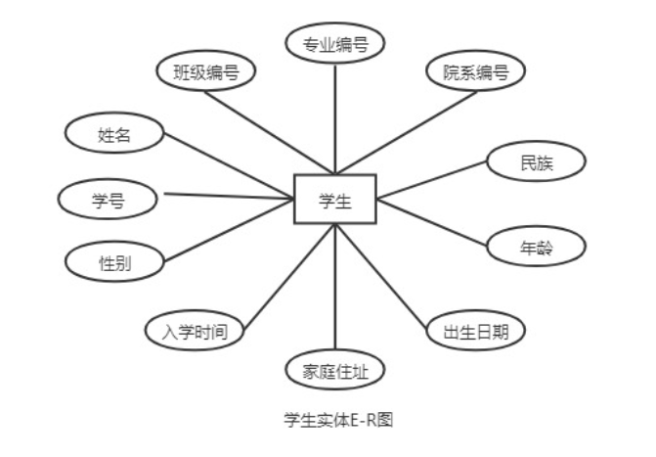

1. .班级实体属性图

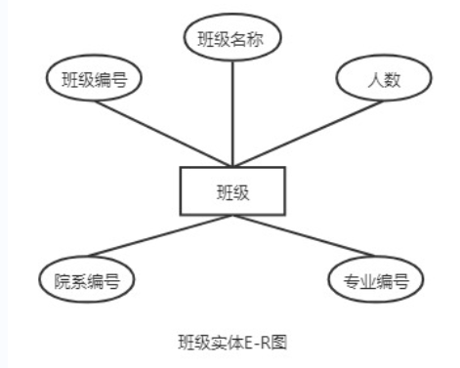

1. .专业实体属性图

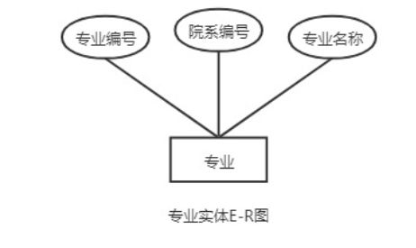

1. .院系实体属性图

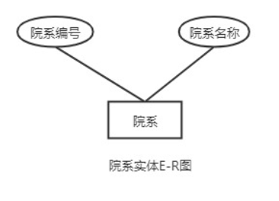

1. .课程实体属性图

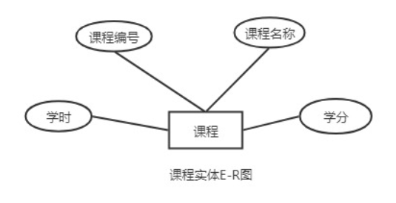

1. .课程成绩实体属性图

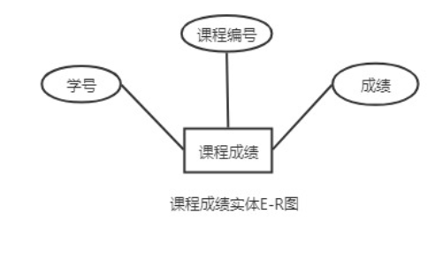

(7).奖惩实体属性图

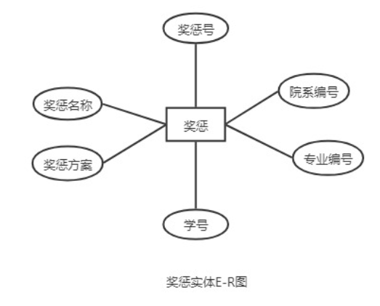

3.3 全局E-R图

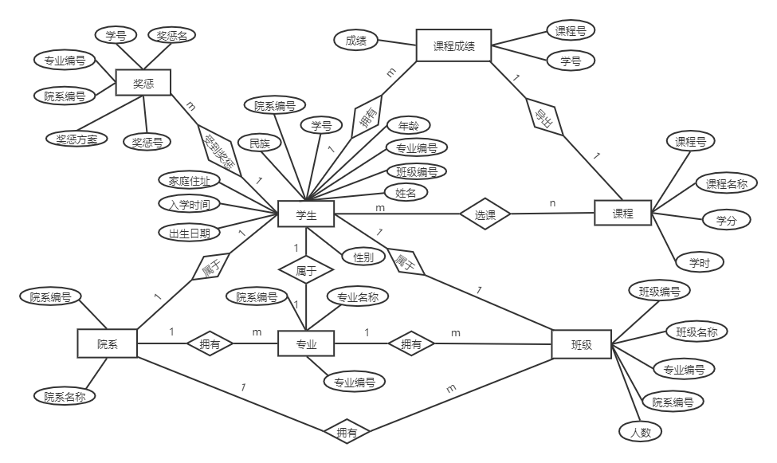

**4．逻辑结构设计**

关系数据模式

（1）学生（学号，姓名，性别，班级编号，专业编号，院系编号，民族，年龄，出生日期，家庭地址，入学时间）

（2）班级（班级编号，专业编号，院系编号，班级名称，人数）

（3）专业（专业编号，院系编号，专业名称）

（4）院系（院系编号、院系名称）

（5）课程（课程号，课程名，学分，学时）

（6）课程成绩（课程号，学号，成绩）

（7）奖惩（奖惩号，学号，专业编号，院系编号，奖惩名称，奖惩方案）

**5．数据库物理设计与实施**

5.1数据库关系图

根据概念结构设计和逻辑结构的内容，可以将此学籍管理系统设计出7个表，分别为“Student表”、“Class表”、“Major表”、“Department表”、“Course表”、“Grader表”和“Award_punish表”。具体如下：

这7张表的数据库关系图如下：

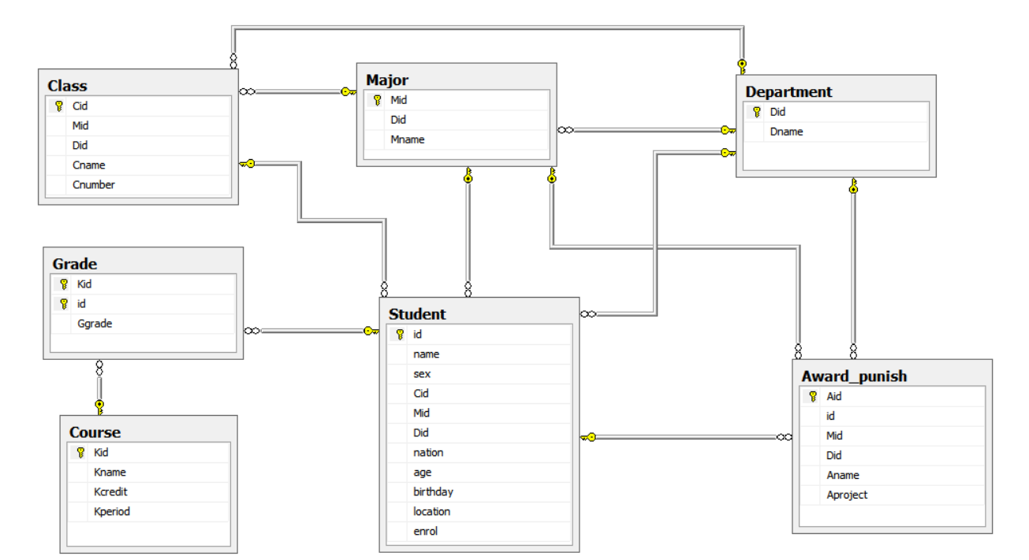

5.2表的创建

1.Department表

|  |  |  |  |
| --- | --- | --- | --- |
| 列名 | 数据类型 | 约束 | 说明 |
| Did | varchar(30) | primary key | 院系编号 |
| Dname | varchar(30) | not null | 院系名称 |

相应的sql语句如下：

create table Department(

Did varchar(30) primary key not null,

Dname varchar(30) not null,

)

2.Major表

|  |  |  |  |
| --- | --- | --- | --- |
| 列名 | 数据类型 | 约束 | 说明 |
| Mid | varchar(30) | primary key | 专业编号 |
| Did | varchar(30) | foreign key | 院系编号 |
| Mname | varchar(30) | not null | 专业名称 |

相应的sql语句如下：

create table Major(

Mid varchar(30) primary key not null,

Did varchar(30) not null,

Mname varchar(30) not null,

foreign key (Did) references Department (Did)

on delete cascade

/*当删除Department表中元组时，级联删除Major表中相应的元组*/

on update cascade,

/*当更新Department表中Did时，级联更新Major表中相应的元组*/

)

3.Class表

|  |  |  |  |
| --- | --- | --- | --- |
| 列名 | 数据类型 | 约束 | 说明 |
| Cid | varchar(30) | primary key | 班级编号 |
| Mid | varchar(30) | foreign key | 专业编号 |
| Did | varchar(30) | foreign key | 院系编号 |
| Cname | varchar(30) | not null | 班级名称 |
| Cnumber | int | not null | 班级人数 |

相应的sql语句如下：

create table Class(

Cid varchar(30) primary key not null,

Mid varchar(30) not null,

Did varchar(30) not null,

Cname varchar(30) not null,

Cnumber int not null,

foreign key (Did) references Department (Did)

on delete cascade

/*当删除Department表中元组时，级联删除Class表中相应的元组*/

on update cascade,

/*当更新Department表中Did时，级联更新Class表中相应的元组*/

foreign key (Mid) references Major (Mid)

on delete no action

/*当删除Major表中的元组造成与Class表不一致时，拒绝删除*/

on update no action,

/*当更新Major表中的元组造成与Class表不一致时，拒绝更新*/

)

4.Student表

|  |  |  |  |
| --- | --- | --- | --- |
| 列名 | 数据类型 | 约束 | 说明 |
| id | varchar(20) | primary key | 学号 |
| name | varchar(20) | not null | 姓名 |
| sex | char(2) | not null | 性别 |
| Cid | varchar(30) | foreign key | 班级编号 |
| Mid | varchar(30) | foreign key | 专业编号 |
| Did | varchar(30) | foreign key | 院系编号 |
| nation | varchar(20) | not null | 民族 |
| age | int | not null | 年龄 |
| birthday | date | not null | 出生日期 |
| location | varchar(20) | not null | 家庭地址 |
| enrol | date | not null | 入学时间 |

相应的sql语句如下：

create table Student(

id varchar(20) primary key not null,

name varchar(20) not null,

sex char(2) not null check(sex in('男','女')),

Cid varchar(30) not null,

Mid varchar(30) not null,

Did varchar(30) not null,

nation varchar(20) not null,

age int not null,

birthday date not null,

location varchar(20) not null,

enrol date not null,

foreign key (Cid) references Class (Cid)

on delete cascade

/*当删除Class表中元组时，级联删除Student表中相应的元组*/

on update cascade,

/*当更新Class表中元组时，级联更新Student表中相应的元组*/

foreign key (Mid) references Major (Mid)

on delete no action

/*当删除Major表中的元组造成与Student表不一致时，拒绝删除*/

on update no action,

/*当更新Major表中的元组造成与Student表不一致时，拒绝更新*/

foreign key (Did) references Department (Did)

on delete no action

/*当删除Department 表中的元组造成与Student表不一致时，拒绝删除*/

on update no action,

/*当更新Department 表中的元组造成与Student表不一致时，拒绝更新*/

)

5.Course表

|  |  |  |  |
| --- | --- | --- | --- |
| 列名 | 数据类型 | 约束 | 说明 |
| Kid | varchar(30) | primary key | 课程编号 |
| Kname | varchar(30) | not null | 课程名称 |
| Kcredit | int | not null | 学分 |
| Kperiod | int | not null | 学时 |

相应的sql语句如下：

create table Course(

Kid varchar(30) primary key not null,

Kname varchar(30) not null,

Kcredit int not null,

Kperiod int not null,

)

6.Grade表

|  |  |  |  |
| --- | --- | --- | --- |
| 列名 | 数据类型 | 约束 | 说明 |
| Kid | varchar(30) | primary key | 课程编号 |
| id | varchar(20) | primary key | 学号 |
| Ggrade | int | not null | 成绩 |

相应的sql语句如下：

create table Grade(

Kid varchar(30) not null,

id varchar(20) not null,

Ggrade int not null,

primary key(Kid,id),

foreign key (Kid) references Course (Kid)

on delete cascade

/*当删除Course 表中元组时，级联删除Grade表中相应的元组*/

on update cascade,

/*当更新Course 表中元组时，级联更新Grade表中相应的元组*/

foreign key (id) references Student (id)

on delete cascade

/*当删除Student 表中元组时，级联删除Grade表中相应的元组*/

on update cascade,

/*当更新Student 表中元组时，级联更新Grade表中相应的元组*/

)

7.Award_punish（奖惩表）

|  |  |  |  |
| --- | --- | --- | --- |
| 列名 | 数据类型 | 约束 | 说明 |
| Aid | varchar(20) | primary key | 奖惩号 |
| id | varchar(20) | foreign key | 学号 |
| Mid | varchar(30) | foreign key | 专业编号 |
| Did | varchar(30) | foreign key | 院系编号 |
| Aname | varchar(30) | not null | 奖惩名称 |
| Aproject | varchar(100) | not null | 奖惩方案 |

相应的sql语句如下：

create table Award_punish(

Aid varchar(20) primary key not null,

id varchar(20) not null,

Mid varchar(30) not null,

Did varchar(30) not null,

Aname varchar(30) not null,

Aproject varchar(100) not null,

foreign key (id) references Student (id)

on delete cascade

/*当删除Student 表中元组时，级联删除Award_punish表中相应的元组*/

on update cascade,

/*当更新Student 表中元组时，级联更新Award_punish表中相应的元组*/

foreign key (Mid) references Major (Mid)

on delete no action

/*当删除Major 表中的元组造成与Award_punish表不一致时，拒绝删除*/

on update no action,

/*当更新Major 表中的元组造成与Award_punish表不一致时，拒绝更新*/

foreign key (Did) references Department (Did)

on delete no action

/*当删除Department 表中的元组造成与Award_punish表不一致时，拒绝删除*/

on update no action,

/*当更新Department 表中的元组造成与Award_punish表不一致时，拒绝更新*/

)

**6．数据操作要求及实现**

根据需求分析中给出的数据处理要求，设计数据库的具体要求，并用SQL加以实现，报告中可只选取部分重点功能加以描述。

6.1 数据查询、更新、删除操作

1.查询年龄小于20的学生的基本信息，SQL语句如下：

select * from Student where age < 20

查询结果如下图所示。

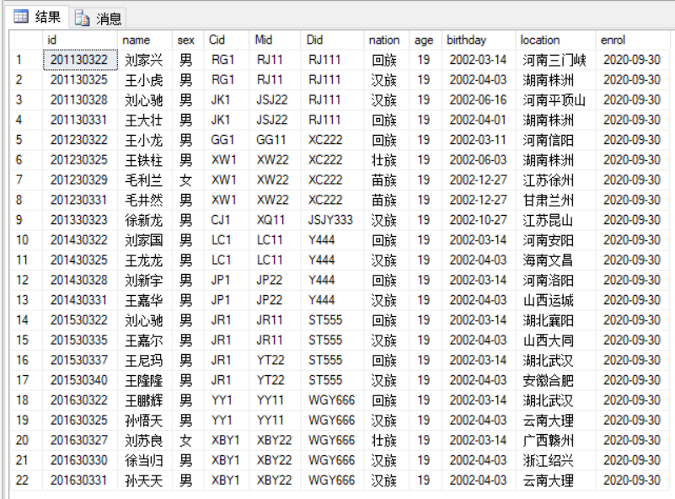

2.查询班级为“软工一班”，且家庭住址的省会为“河南”的学生基本信息，SQL语句如下：

select * from Student where Cid = 'RG1' and location like '河南%'

查询结果如下图所示。

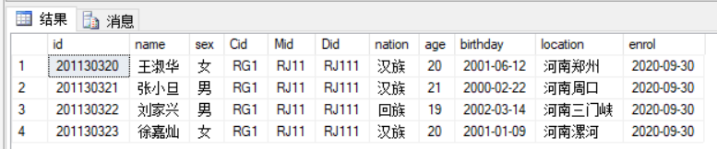

3.查询选修了“SJK3”课程的学生的学号、姓名、成绩，其中按照成绩从大到小的顺序排列，SQL语句如下：

select Student.id,name,Ggrade from Student,Grade

where Student.id = Grade.id and Grade.Kid = 'SJK3'

order by Ggrade desc

查询结果如下图所示。

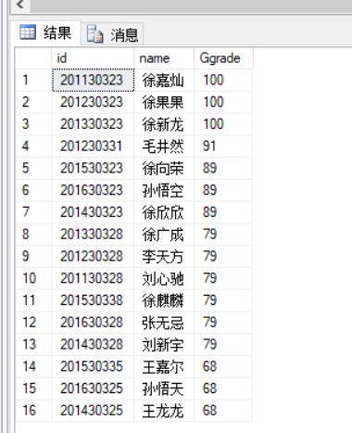

4.查询选修“大学英语”课程所有学生的平均成绩，SQL语句如下：

select avg(Ggrade) 平均成绩 from Grade,Course

where Grade.Kid = Course.Kid

and Course.Kname = '大学英语'

查询结果如下图所示。

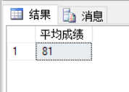

5.查询获得“三好学生”称号的学生的学号、姓名、专业编号、院系编号，SQL语句如下：

select Student.id 学号,name 姓名,Mname 专业名称,Dname 院系名称

from Student,Major,Department,Award_punish

where Student.id = Award_punish.id

and Major.Mid = Award_punish.Mid

and Department.Did = Award_punish.Did

and Aname = '三好学生'

查询结果如下图所示。

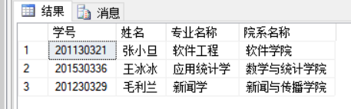

6.将家庭地址为“江苏南京”的学生的家庭地址更改为“河南郑州”，SQL语句如下：

update Student set location = '河南郑州' where location = '江苏南京'

更改结果如下图所示。

更改前：

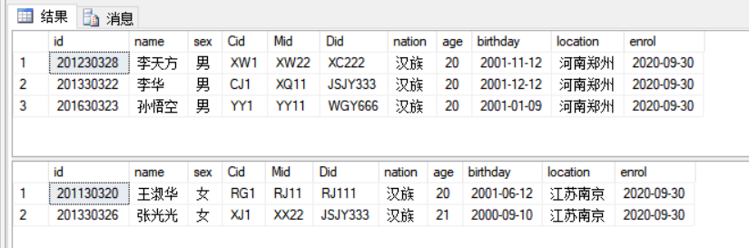

更改后：

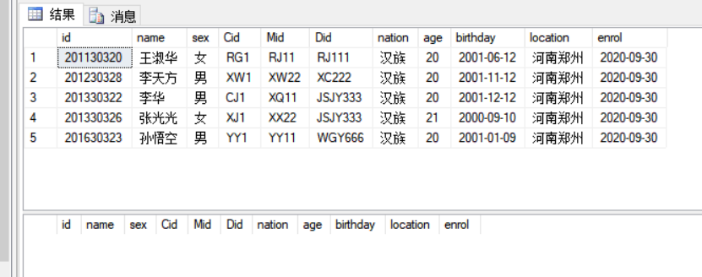

7.将课程“大学英语"的学时更改为68，SQL语句如下：

update Course set Kperiod = 68 where Kname = '大学英语'，更改结果如下图所示。

更改前：

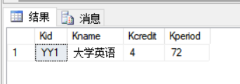

更改后：

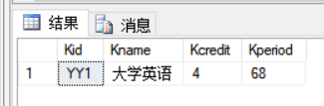

8.删除学号为“”学生的奖惩信息，SQL语句如下：

delete from Award_punish where id = '201130321'，删除结果如下图所示。

删除前：

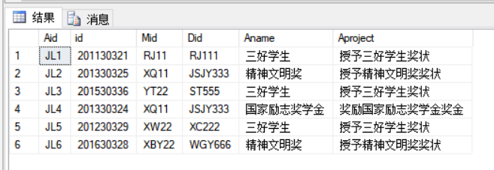

删除后：

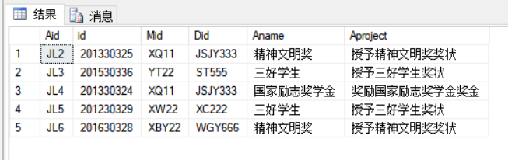

6.2 视图

1：创建学生基本信息视图，实现查询各个学生的学号、姓名、班级编号、专业编号、院系编号，SQL语句如下：

create view A_Student(id,name,Cname,Mname,Dname)

as

select id,name,Cname,Mname,Dname

from Student,Class,Major,Department

where Class.Did = Department.Did

and Class.Mid = Major.Mid

and Student.Did = Department.Did

and Student.Mid = Major.Mid

with check option

视图的执行结果如下：

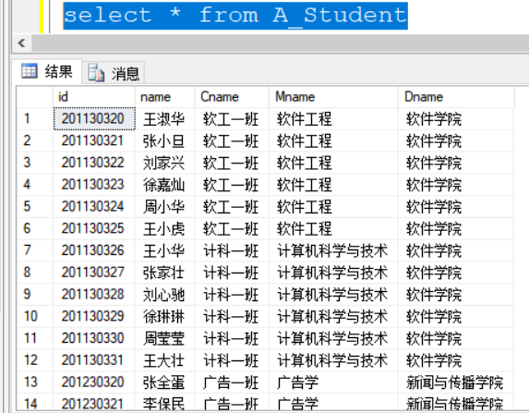

2：创建学生成绩视图，实现查询各个学生的学号、姓名、课程、成绩，SQL语句如下：

create view B_Grade(id,name,Kname,Ggrade)

as

select Student.id,name,Kname,Ggrade

from Student,Grade,Course

where Student.id = Grade.id

and Grade.Kid = Course.Kid

with check option

视图的执行结果如下：

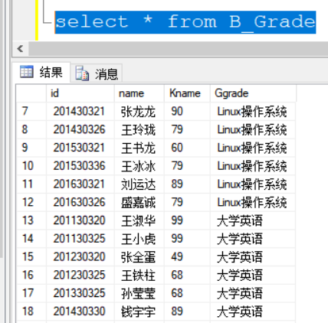

3：创建学生奖惩视图，实现查询各个学生的学号、姓名、班级、专业、院系、奖惩号、奖惩名、奖惩方案，SQL语句如下：

create view C_Award_punish

(id,name,Cname,Mname,Dname,Aid,Aname,Aproject)

as

select Student.id,name,Cname,Mname,Dname,Aid,Aname,Aproject

from Student,Class,Major,Department,Award_punish

where Student.id = Award_punish.id

and Award_punish.Mid = Major.Mid

and Award_punish.Did = Department.Did

and Class.Did = Department.Did

and Class.Mid = Major.Mid

with check option

视图的执行结果如下：

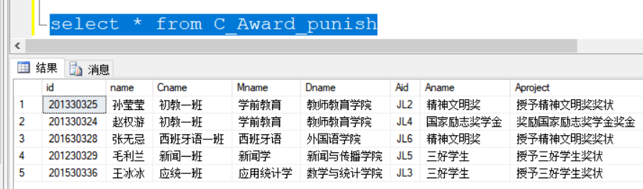

6.3 触发器

1.创建触发器，当增加学生班级信息时自动修改相应班级学生人数，SQL语句如下：

create trigger insert_stu

on Student for insert

as

begin

declare @cid varchar(30)

select @cid=Cid from inserted

update Class set Cnumber = Cnumber + 1 where Cid = @cid

end

在Student表中插入一条数据：

insert into Student values('201130332','陈思宇','男','RG1','RJ11','RJ111','汉族',20,'2001-02-03','海南文昌','2020-09-30')

执行结果如下：

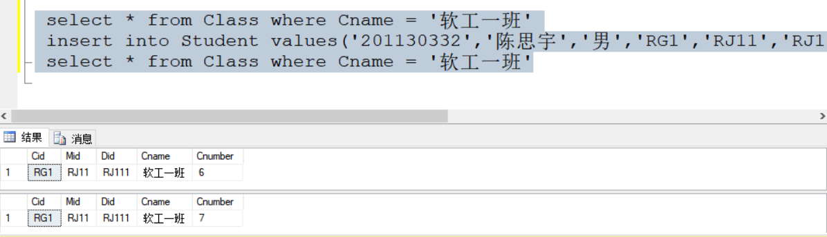

2.创建触发器，当删除学生班级信息时自动修改相应班级学生人数，SQL语句如下：

create trigger delete_stu

on Student for delete

as

begin

declare @cid varchar(30)

select @cid=Cid from deleted

update Class set Cnumber = Cnumber - 1 where Cid = @cid

end

在Student表中删除一条数据：

delete from Student where name = '陈思宇'

执行结果如下：

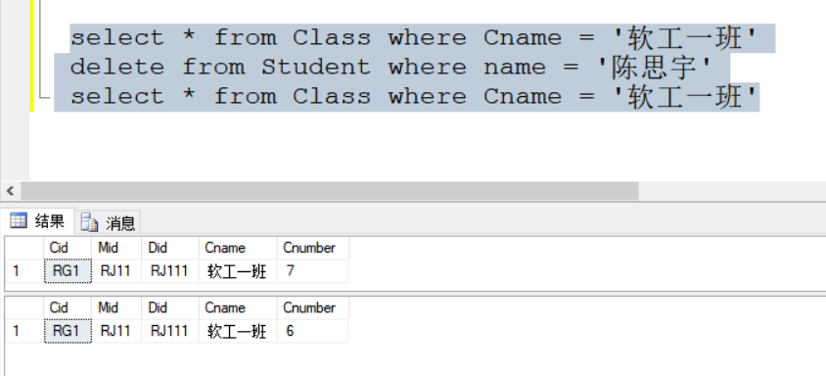

3.创建触发器，当修改学生班级信息时自动修改相应班级学生人数，SQL语句如下：

create trigger update_stu

on Student for update

as

begin

declare @cid1 varchar(30)

declare @cid2 varchar(30)

--存放更新前的数据

select @cid1=Cid from deleted

--存放更新后的数据

select @cid2=Cid from inserted

update Class set Cnumber = Cnumber - 1 where Cid = @cid1

update Class set Cnumber = Cnumber + 1 where Cid = @cid2

end

在Student表中更改一条数据，将王小虎的班级“RG1”更改为“YY1”

update Student set Cid = 'YY1' where name = '王小虎'

执行结果如下：

更改前：

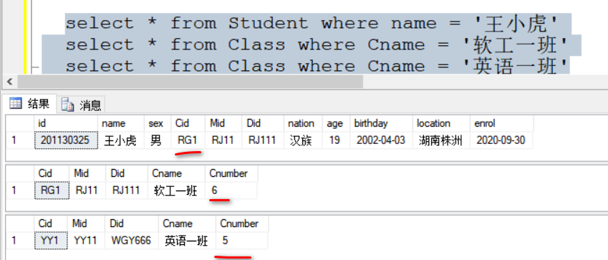

更改后:

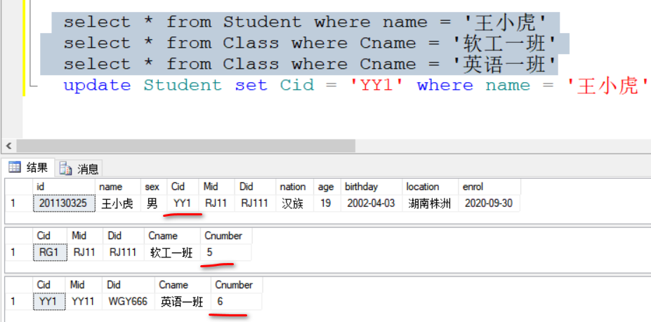

6.4 存储过程

1.创建存储过程查询指定学生的成绩单,SQL语句如下：

create procedure pro_grade

@id varchar(30)=null,

@name varchar(30)=null

as

if(@id is null or @name is null )

begin

print '请输入学号与姓名！'

end

else if(

(select name from Student where id = @id) != @name

or (select id from Student where name = @name) != @id

)

begin

print '输入有误！'

end

else

begin

select Student.id,name,Kname,Ggrade

from Student,Grade,Course

where Student.id = Grade.id

and Grade.Kid = Course.Kid

and name = @name

end

go

执行结果如下：

1.当未输入学号或姓名时，提示“请输入学号与姓名！”

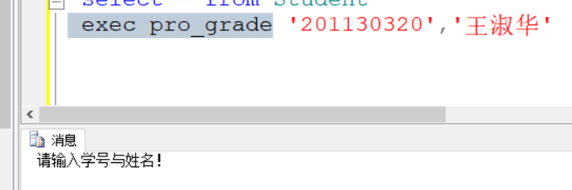 2.当输入信息有误时，提示“输入有误！”

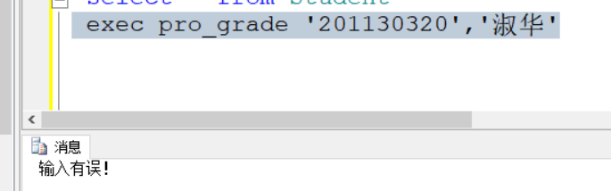

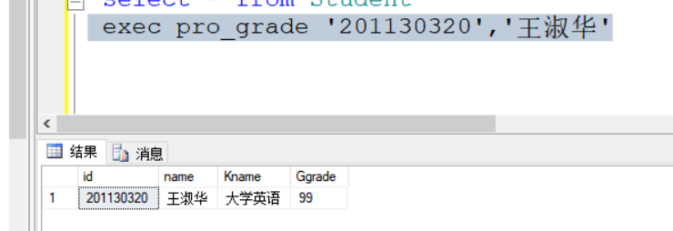 3.当输入正确的学号和姓名时，打印出该学生的成绩单。

**7．总结**

在本学期末，我通过此次数据库课程设计，对本学期所学的数据库知识进行了系统化梳理。在此次课程设计任务中，我的选题为“高校学籍管理系统”，之所以会选择这个题型，是因为我觉得“高校学籍管理”更与我想贴近，我本身作为一个学生，在学生学籍管理这方面还是有一定的了解的。所以在课程设计的需求分析以及概念结构设计的过程中，操作起来也能够得心应手。

在本学期学习SQL Server数据库之前，我就对MySQL数据库有了一定的学习，两者同为关系数据库管理系统，各自都有着自己的优点。比如SQL Server数据库扩展性强、安全性高、具有可维护性。MySQL数据库性能出色、适用于所有平台[2]。在两者的联系上，SQL Server的基本语法和MySQL基本相同，即相应的增、删、改、查操作。我在学习MySQL数据库时，主要是学习数据库的数据处理，对现有数据进行增、删、改、查，以及利用JDBC技术连接Java代码和数据库。所以本学期学习SQL Server数据库弥补我之前学习MySQL数据库的存在的不足。

在本次课程设计中，我掌握了数据库设计的步骤，以及各个阶段的相应内容，在实现数据库的基础操作增、删、改、查的同时，还实现了视图、触发器、存储过程的创建，对数据的处理方式更加多样，这对于我来说对关系数据库关系系统更加了解。

总的来说，通过此次数据库课程设计，使我对本学期的SQL Server数据库知识有了系统化的运用，不仅对之前所学的知识进行了回顾，也对现学的知识进行了实地化操作。这对于我来说受益匪浅。

1. **参考文献**
2. 任菊香.职业本科教育教学策略探究——以《数据库原理与应用》课程为例[J].办公自动化,2021,26(24):35-37.
3. 陈伟莲.SQL Server数据表范式细化设计教学研究[J].计算机时代,2021(10):96-98+102.DOI:10.16644/j.cnki.cn33-1094/tp.2021.10.025.
4. **附录**

**一：学生管理系统文件**

create database Stu_status

--学生表

create table Student(

id varchar(20) primary key not null,

name varchar(20) not null,

sex char(2) not null check(sex in('男','女')),

Cid varchar(30) not null,

Mid varchar(30) not null,

Did varchar(30) not null,

nation varchar(20) not null,

age int not null,

birthday date not null,

location varchar(20) not null,

enrol date not null,

foreign key (Cid) references Class (Cid)

on delete cascade

on update cascade,

foreign key (Mid) references Major (Mid)

on delete no action

on update no action,

foreign key (Did) references Department (Did)

on delete no action

on update no action,

)

--院系表

create table Department(

Did varchar(30) primary key not null,

Dname varchar(30) not null,

)

--专业表

create table Major(

Mid varchar(30) primary key not null,

Did varchar(30) not null,

Mname varchar(30) not null,

foreign key (Did) references Department (Did)

on delete cascade

on update cascade,

)

--班级表

create table Class(

Cid varchar(30) primary key not null,

Mid varchar(30) not null,

Did varchar(30) not null,

Cname varchar(30) not null,

Cnumber int not null,

foreign key (Did) references Department (Did)

on delete cascade

on update cascade,

foreign key (Mid) references Major (Mid)

on delete no action

on update no action,

)

--课程表

create table Course(

Kid varchar(30) primary key not null,

Kname varchar(30) not null,

Kcredit int not null,

Kperiod int not null,

)

--课程成绩表

create table Grade(

Kid varchar(30) not null,

id varchar(20) not null,

Ggrade int not null,

primary key(Kid,id),

foreign key (Kid) references Course (Kid)

on delete cascade

on update cascade,

foreign key (id) references Student (id)

on delete cascade

on update cascade,

)

--奖惩表

create table Award_punish(

Aid varchar(20) primary key not null,

id varchar(20) not null,

Mid varchar(30) not null,

Did varchar(30) not null,

Aname varchar(30) not null,

Aproject varchar(100) not null,

foreign key (id) references Student (id)

on delete cascade

on update cascade,

foreign key (Mid) references Major (Mid)

on delete no action

on update no action,

foreign key (Did) references Department (Did)

on delete no action

on update no action,

)

select * from Department

insert into Department values('RJ111','软件学院')

insert into Department values('XC222','新闻与传播学院')

insert into Department values('JSJY333','教师教育学院')

insert into Department values('Y444','医学院')

insert into Department values('ST555','数学与统计学院')

insert into Department values('WGY666','外国语学院')

insert into Department values('DQ777','电气与机械工程学院')

select * from Major

insert into Major values('RJ11','RJ111','软件工程')

insert into Major values('JSJ22','RJ111','计算机科学与技术')

insert into Major values('GG11','XC222','广告学')

insert into Major values('XW22','XC222','新闻学')

insert into Major values('XQ11','JSJY333','学前教育')

insert into Major values('XX22','JSJY333','小学教育')

insert into Major values('LC11','Y444','临床医学')

insert into Major values('JP22','Y444','解剖学')

insert into Major values('JR11','ST555','金融工程')

insert into Major values('YT22','ST555','应用统计学')

insert into Major values('YY11','WGY666','英语')

insert into Major values('XBY22','WGY666','西班牙语')

insert into Major values('JD11','DQ777','机械电子工程')

insert into Major values('DZ22','DQ777','电气工程及其自动化')

select * from Class

insert into Class values('RG1','RJ11','RJ111','软工一班',6)

insert into Class values('JK1','JSJ22','RJ111','计科一班',6)

insert into Class values('GG1','GG11','XC222','广告一班',5)

insert into Class values('XW1','XW22','XC222','新闻一班',7)

insert into Class values('CJ1','XQ11','JSJY333','初教一班',6)

insert into Class values('XJ1','XX22','JSJY333','小教一班',5)

insert into Class values('LC1','LC11','Y444','临床一班',6)

insert into Class values('JP1','JP22','Y444','解剖一班',6)

insert into Class values('JR1','JR11','ST555','金融一班',5)

insert into Class values('YT1','YT22','ST555','应统一班',5)

insert into Class values('YY1','YY11','WGY666','英语一班',5)

insert into Class values('XBY1','XBY22','WGY666','西班牙语一班',6)

select * from Student

insert into Student values('201130320','王淑华','女','RG1','RJ11','RJ111','汉族',20,'2001-06-12','河南郑州','2020-09-30')

insert into Student values('201130321','张小旦','男','RG1','RJ11','RJ111','汉族',21,'2000-02-22','河南周口','2020-09-30')

insert into Student values('201130322','刘家兴','男','RG1','RJ11','RJ111','回族',19,'2002-03-14','河南三门峡','2020-09-30')

insert into Student values('201130323','徐嘉灿','女','RG1','RJ11','RJ111','汉族',20,'2001-01-09','河南漯河','2020-09-30')

insert into Student values('201130324','周小华','女','RG1','RJ11','RJ111','汉族',20,'2001-02-03','四川成都','2020-09-30')

insert into Student values('201130325','王小虎','男','RG1','RJ11','RJ111','汉族',19,'2002-04-03','湖南株洲','2020-09-30')

insert into Student values('201130326','王小华','女','JK1','JSJ22','RJ111','汉族',20,'2001-02-11','新疆喀什','2020-09-30')

insert into Student values('201130327','张家壮','男','JK1','JSJ22','RJ111','汉族',21,'2000-02-22','河南周口','2020-09-30')

insert into Student values('201130328','刘心驰','男','JK1','JSJ22','RJ111','汉族',19,'2002-06-16','河南平顶山','2020-09-30')

insert into Student values('201130329','徐琳琳','女','JK1','JSJ22','RJ111','汉族',20,'2001-08-09','河南漯河','2020-09-30')

insert into Student values('201130330','周莹莹','女','JK1','JSJ22','RJ111','汉族',20,'2001-02-02','四川重庆','2020-09-30')

insert into Student values('201130331','王大壮','男','JK1','JSJ22','RJ111','回族',19,'2002-04-01','湖南株洲','2020-09-30')

insert into Student values('201230320','张全蛋','男','GG1','GG11','XC222','汉族',20,'2001-01-10','四川成都','2020-09-30')

insert into Student values('201230321','李保民','男','GG1','GG11','XC222','汉族',21,'2000-02-22','河南周口','2020-09-30')

insert into Student values('201230322','王小龙','男','GG1','GG11','XC222','回族',19,'2002-03-11','河南信阳','2020-09-30')

insert into Student values('201230323','徐果果','女','GG1','GG11','XC222','汉族',20,'2001-07-09','河南漯河','2020-09-30')

insert into Student values('201230324','周大山','男','GG1','GG11','XC222','汉族',20,'2001-02-04','上海浦东','2020-09-30')

insert into Student values('201230325','王铁柱','男','XW1','XW22','XC222','壮',19,'2002-06-03','湖南株洲','2020-09-30')

insert into Student values('201230326','赵中华','男','XW1','XW22','XC222','汉',20,'2000-07-19','浙江绍兴','2020-09-30')

insert into Student values('201230327','孙苗苗','女','XW1','XW22','XC222','汉',21,'2000-09-10','江苏苏州','2020-09-30')

insert into Student values('201230328','李天方','男','XW1','XW22','XC222','汉',20,'2001-11-12','江苏南京','2020-09-30')

insert into Student values('201230329','毛利兰','女','XW1','XW22','XC222','苗',19,'2002-12-27','江苏徐州','2020-09-30')

insert into Student values('201230330','张大虎','男','XW1','XW22','XC222','汉',20,'2001-11-12','河北天津','2020-09-30')

insert into Student values('201230331','毛井然','男','XW1','XW22','XC222','苗',19,'2002-12-27','甘肃兰州','2020-09-30')

insert into Student values('201330320','刘晓芳','女','CJ1','XQ11','JSJY333','汉族',20,'2000-07-19','浙江绍兴','2020-09-30')

insert into Student values('201330321','孙颖亮','女','CJ1','XQ11','JSJY333','汉族',21,'2000-09-10','江苏苏州','2020-09-30')

insert into Student values('201330322','李华','男','CJ1','XQ11','JSJY333','汉族',20,'2001-12-12','江苏南京','2020-09-30')

insert into Student values('201330323','徐新龙','男','CJ1','XQ11','JSJY333','汉族',19,'2002-10-27','江苏昆山','2020-09-30')

insert into Student values('201330324','赵权游','男','CJ1','XQ11','JSJY333','汉族',20,'2000-01-19','浙江绍兴','2020-09-30')

insert into Student values('201330325','孙莹莹','女','CJ1','XQ11','JSJY333','壮族',21,'2000-09-10','广州佛山','2020-09-30')

insert into Student values('201330326','张光光','女','YT1','XX22','JSJY333','汉',21,'2000-09-10','河南郑州','2020-09-30')

insert into Student values('201330327','李天启','男','YT1','XX22','JSJY333','黎',20,'2001-12-12','江苏镇江','2020-09-30')

insert into Student values('201330328','徐广成','男','YT1','XX22','JSJY333','汉',20,'2001-10-27','广州中山','2020-09-30')

insert into Student values('201330329','赵光华','男','YT1','XX22','JSJY333','汉',20,'2000-01-19','浙江绍兴','2020-09-30')

insert into Student values('201330330','孙小文','女','YT1','XX22','JSJY333','壮',21,'2000-09-10','广州东莞','2020-09-30')

insert into Student values('201430320','王果果','女','LC1','LC11','Y444','汉族',20,'2001-06-12','河南鹤壁','2020-09-30')

insert into Student values('201430321','张龙龙','男','LC1','LC11','Y444','汉族',21,'2000-02-22','安徽合肥','2020-09-30')

insert into Student values('201430322','刘家国','男','LC1','LC11','Y444','回族',19,'2002-03-14','河南安阳','2020-09-30')

insert into Student values('201430323','徐欣欣','女','LC1','LC11','Y444','汉族',20,'2001-01-09','河南漯河','2020-09-30')

insert into Student values('201430324','钱多多','女','LC1','LC11','Y444','汉族',20,'2001-02-03','四川成都','2020-09-30')

insert into Student values('201430325','王龙龙','男','LC1','LC11','Y444','汉族',19,'2002-04-03','海南文昌','2020-09-30')

insert into Student values('201430326','王玲珑','女','JP1','JP22','Y444','壮族',20,'2001-06-12','河南南阳','2020-09-30')

insert into Student values('201430327','张佳慧','男','JP1','JP22','Y444','汉族',21,'2000-02-22','安徽合肥','2020-09-30')

insert into Student values('201430328','刘新宇','男','JP1','JP22','Y444','回族',19,'2002-03-14','河南洛阳','2020-09-30')

insert into Student values('201430329','徐家旺','女','JP1','JP22','Y444','汉族',20,'2001-01-09','河南漯河','2020-09-30')

insert into Student values('201430330','钱宇宇','女','JP1','JP22','Y444','汉族',20,'2001-02-03','河北唐山','2020-09-30')

insert into Student values('201430331','王嘉华','男','JP1','JP22','Y444','汉族',19,'2002-04-03','山西运城','2020-09-30')

insert into Student values('201530321','王书龙','男','JR1','JR11','ST555','汉族',21,'2000-02-22','湖南长沙','2020-09-30')

insert into Student values('201530322','刘心驰','男','JR1','JR11','ST555','回族',19,'2002-03-14','湖北襄阳','2020-09-30')

insert into Student values('201530323','徐向荣','女','JR1','JR11','ST555','汉族',20,'2001-01-09','河南开封','2020-09-30')

insert into Student values('201530334','范期望','男','JR1','JR11','ST555','汉族',20,'2001-02-03','江苏盐城','2020-09-30')

insert into Student values('201530335','王嘉尔','男','JR1','JR11','ST555','汉族',19,'2002-04-03','山西大同','2020-09-30')

insert into Student values('201530336','王冰冰','男','JR1','YT22','ST555','汉族',21,'2000-02-22','湖南岳阳','2020-09-30')

insert into Student values('201530337','王尼玛','男','JR1','YT22','ST555','回族',19,'2002-03-14','湖北武汉','2020-09-30')

insert into Student values('201530338','徐麒麟','女','JR1','YT22','ST555','汉族',20,'2001-01-09','河南周口','2020-09-30')

insert into Student values('201530339','范国家','男','JR1','YT22','ST555','苗族',20,'2001-02-03','江苏盐城','2020-09-30')

insert into Student values('201530340','王隆隆','男','JR1','YT22','ST555','汉族',19,'2002-04-03','安徽合肥','2020-09-30')

insert into Student values('201630321','刘运达','男','YY1','YY11','WGY666','汉族',21,'2000-02-22','江苏扬州','2020-09-30')

insert into Student values('201630322','王鹏辉','男','YY1','YY11','WGY666','回族',19,'2002-03-14','湖北武汉','2020-09-30')

insert into Student values('201630323','孙悟空','男','YY1','YY11','WGY666','汉族',20,'2001-01-09','河南郑州','2020-09-30')

insert into Student values('201630324','孙悟饭','男','YY1','YY11','WGY666','苗族',20,'2001-02-03','江苏盐城','2020-09-30')

insert into Student values('201630325','孙悟天','男','YY1','YY11','WGY666','汉族',19,'2002-04-03','云南大理','2020-09-30')

insert into Student values('201630326','盛嘉诚','男','XBY1','XBY22','WGY666','汉族',21,'2000-02-22','福建温州','2020-09-30')

insert into Student values('201630327','刘苏良','女','XBY1','XBY22','WGY666','壮族',19,'2002-03-14','广西赣州','2020-09-30')

insert into Student values('201630328','张无忌','男','XBY1','XBY22','WGY666','汉族',20,'2001-01-09','湖北遵义','2020-09-30')

insert into Student values('201630329','孙贞建','女','XBY1','XBY22','WGY666','苗族',20,'2001-02-03','河北唐山','2020-09-30')

insert into Student values('201630330','徐当归','男','XBY1','XBY22','WGY666','汉族',19,'2002-04-03','浙江绍兴','2020-09-30')

insert into Student values('201630331','孙天天','男','XBY1','XBY22','WGY666','汉族',19,'2002-04-03','云南大理','2020-09-30')

select * from Course

insert into Course values('YY1','大学英语',4,72)

insert into Course values('GS2','高等数学',4,120)

insert into Course values('SJK3','数据库',4,72)

insert into Course values('SJ4','数据结构',4,72)

insert into Course values('LC5','Linux操作系统',3,68)

select * from Grade

insert into Grade values('YY1','201130320',99)

insert into Grade values('LC5','201130321',96)

insert into Grade values('GS2','201130322',94)

insert into Grade values('SJK3','201130323',100)

insert into Grade values('SJ4','201130324',99)

insert into Grade values('YY1','201130325',99)

insert into Grade values('LC5','201130326',96)

insert into Grade values('GS2','201130327',94)

insert into Grade values('SJK3','201130328',79)

insert into Grade values('SJ4','201130329',99)

insert into Grade values('SJ4','201130330',89)

insert into Grade values('SJ4','201130331',91)

insert into Grade values('YY1','201230320',49)

insert into Grade values('LC5','201230321',90)

insert into Grade values('GS2','201230322',88)

insert into Grade values('SJK3','201230323',100)

insert into Grade values('SJ4','201230324',59)

insert into Grade values('YY1','201230325',68)

insert into Grade values('LC5','201230326',96)

insert into Grade values('GS2','201230327',94)

insert into Grade values('SJK3','201230328',79)

insert into Grade values('SJ4','201230329',99)

insert into Grade values('GS2','201230330',89)

insert into Grade values('SJK3','201230331',91)

insert into Grade values('GS2','201330320',99)

insert into Grade values('LC5','201330321',90)

insert into Grade values('GS2','201330322',88)

insert into Grade values('SJK3','201330323',100)

insert into Grade values('SJ4','201330324',79)

insert into Grade values('YY1','201330325',68)

insert into Grade values('LC5','201330326',79)

insert into Grade values('GS2','201330327',70)

insert into Grade values('SJK3','201330328',79)

insert into Grade values('SJ4','201330329',99)

insert into Grade values('GS2','201330330',89)

insert into Grade values('GS2','201430320',69)

insert into Grade values('LC5','201430321',90)

insert into Grade values('GS2','201430322',88)

insert into Grade values('SJK3','201430323',89)

insert into Grade values('SJ4','201430324',79)

insert into Grade values('SJK3','201430325',68)

insert into Grade values('LC5','201430326',79)

insert into Grade values('GS2','201430327',70)

insert into Grade values('SJK3','201430328',79)

insert into Grade values('SJ4','201430329',62)

insert into Grade values('YY1','201430330',89)

insert into Grade values('GS2','201430331',89)

insert into Grade values('LC5','201530321',60)

insert into Grade values('GS2','201530322',88)

insert into Grade values('SJK3','201530323',89)

insert into Grade values('SJ4','201530334',79)

insert into Grade values('SJK3','201530335',68)

insert into Grade values('LC5','201530336',79)

insert into Grade values('GS2','201530337',70)

insert into Grade values('SJK3','201530338',79)

insert into Grade values('SJ4','201530339',100)

insert into Grade values('YY1','201530340',89)

insert into Grade values('LC5','201630321',89)

insert into Grade values('GS2','201630322',88)

insert into Grade values('SJK3','201630323',89)

insert into Grade values('SJ4','201630324',79)

insert into Grade values('SJK3','201630325',68)

insert into Grade values('LC5','201630326',79)

insert into Grade values('GS2','201630327',70)

insert into Grade values('SJK3','201630328',79)

insert into Grade values('SJ4','201630329',62)

insert into Grade values('YY1','201630330',89)

insert into Grade values('GS2','201630331',89)

select * from Award_punish

insert into Award_punish values('JL1','201130321','RJ11','RJ111','三好学生','授予三好学生奖状')

insert into Award_punish values('JL2','201330325','XQ11','JSJY333','精神文明奖','授予精神文明奖奖状')

insert into Award_punish values('JL3','201530336','YT22','ST555','三好学生','授予三好学生奖状')

insert into Award_punish values('JL4','201330324','XQ11','JSJY333','国家励志奖学金','奖励国家励志奖学金奖金')

insert into Award_punish values('JL5','201230329','XW22','XC222','三好学生','授予三好学生奖状')

insert into Award_punish values('JL6','201630328','XBY22','WGY666','精神文明奖','授予精神文明奖奖状')

**二：学籍管理数据操作**

--查询年龄小于的学生的基本信息

select * from Student where age < 20

--查询班级为“软工一班”，且家庭住址的省会为“河南”的学生基本信息

select * from Student where Cid = 'RG1' and location like '河南%'

--查询选修了“SJK3”课程的学生的学号、姓名、成绩，其中按照成绩从大到小的顺序排列

select Student.id,name,Ggrade from Student,Grade

where Student.id = Grade.id and Grade.Kid = 'SJK3'

order by Ggrade desc

--查询选修“大学英语”课程所有学生的平均成绩

select avg(Ggrade) 平均成绩 from Grade,Course

where Grade.Kid = Course.Kid

and Course.Kname = '大学英语'

--查询获得“三好学生”称号的学生的学号、姓名、专业、院系

select Student.id 学号,name 姓名,Mname 专业名称,Dname 院系名称

from Student,Major,Department,Award_punish

where Student.id = Award_punish.id

and Major.Mid = Award_punish.Mid

and Department.Did = Award_punish.Did

and Aname = '三好学生'

--将家庭地址为“江苏南京”的学生的家庭地址更改为“河南郑州”

select * from Student where location = '河南郑州'

select * from Student where location = '江苏南京'

update Student set location = '河南郑州' where location = '江苏南京'

--将课程“大学英语"的学时更改为

select * from Course where Kname = '大学英语'

update Course set Kperiod = 68 where Kname = '大学英语'

--删除学号为“”学生的奖惩信息

select * from Award_punish

delete from Award_punish where id = '201130321'

--创建视图，实现查询各个学生的学号、姓名、班级编号、专业编号、院系编号。

create view A_Student(id,name,Cname,Mname,Dname)

as

select id,name,Cname,Mname,Dname

from Student,Class,Major,Department

where Class.Did = Department.Did

and Class.Mid = Major.Mid

and Student.Did = Department.Did

and Student.Mid = Major.Mid

with check option

select * from A_Student

--创建学生成绩视图，实现查询各个学生的学号、姓名、课程、成绩

create view B_Grade(id,name,Kname,Ggrade)

as

select Student.id,name,Kname,Ggrade

from Student,Grade,Course

where Student.id = Grade.id

and Grade.Kid = Course.Kid

with check option

select * from B_Grade

--创建学生奖惩视图，实现查询各个学生的学号、姓名、班级、专业、院系、奖惩号、奖惩名、奖惩方案

create view C_Award_punish(id,name,Cname,Mname,Dname,Aid,Aname,Aproject)

as

select Student.id,name,Cname,Mname,Dname,Aid,Aname,Aproject

from Student,Class,Major,Department,Award_punish

where Student.id = Award_punish.id

and Award_punish.Mid = Major.Mid

and Award_punish.Did = Department.Did

and Class.Did = Department.Did

and Class.Mid = Major.Mid

with check option

select * from C_Award_punish

--创建触发器，当增加学生班级信息时自动修改相应班级学生人数

create trigger insert_stu

on Student for insert

as

begin

declare @cid varchar(30)

select @cid=Cid from inserted

update Class set Cnumber = Cnumber + 1 where Cid = @cid

end

select * from Class where Cname = '软工一班'

insert into Student values('201130332','陈思宇','男','RG1','RJ11','RJ111','汉族',20,'2001-02-03','海南文昌','2020-09-30')

select * from Class where Cname = '软工一班'

--创建触发器，当删除学生班级信息时自动修改相应班级学生人数

create trigger delete_stu

on Student for delete

as

begin

declare @cid varchar(30)

select @cid=Cid from deleted

update Class set Cnumber = Cnumber - 1 where Cid = @cid

end

select * from Class where Cname = '软工一班'

delete from Student where name = '陈思宇'

select * from Class where Cname = '软工一班'

--创建触发器，当修改学生班级信息时自动修改相应班级学生人数

create trigger update_stu

on Student for update

as

begin

declare @cid1 varchar(30)

declare @cid2 varchar(30)

--存放更新前的数据

select @cid1=Cid from deleted

--存放更新后的数据

select @cid2=Cid from inserted

update Class set Cnumber = Cnumber - 1 where Cid = @cid1

update Class set Cnumber = Cnumber + 1 where Cid = @cid2

end

select * from Student where name = '王小虎'

select * from Class where Cname = '软工一班'

select * from Class where Cname = '英语一班'

update Student set Cid = 'YY1' where name = '王小虎'

--创建存储过程查询指定学生的成绩单

create procedure pro_grade

@id varchar(30)=null,

@name varchar(30)=null

as

if(@id is null or @name is null )

begin

print '请输入学号与姓名！'

end

else if(

(select name from Student where id = @id) != @name

or (select id from Student where name = @name) != @id

)

begin

print '输入有误！'

end

else

begin

select Student.id,name,Kname,Ggrade

from Student,Grade,Course

where Student.id = Grade.id

and Grade.Kid = Course.Kid

and name = @name

end

go

select * from Student

exec pro_grade '201130320','王淑华'